name: "CaffeNet"
layer {
name: "data"
type: "Data"
top: "data"
top: "label"
include {
phase: TRAIN
}
transform_param {
mirror: true
crop_size: 227
mean_file: "${mean_file}"
}
data_param {
source: "${train_lmdb}"
batch_size: 256
backend: LMDB
}
}
layer {
name: "data"
type: "Data"
top: "data"
top: "label"
include {
phase: TEST
}
transform_param {
mirror: false
crop_size: 227
mean_file: "${mean_file}"
}
data_param {
source: "${validation_lmdb}"
batch_size: 50
backend: LMDB
}
}
layer {
name: "conv1"
type: "Convolution"
bottom: "data"
top: "conv1"
param {
lr_mult: 1
decay_mult: 1
}
param {
lr_mult: 2
decay_mult: 0
}
convolution_param {
num_output: 96
kernel_size: 11
stride: 4
weight_filler {
type: "gaussian"
std: 0.01
}
bias_filler {
type: "constant"
value: 0
}
}
}
layer {
name: "relu1"
type: "ReLU"
bottom: "conv1"
top: "conv1"
}
layer {
name: "pool1"
type: "Pooling"
bottom: "conv1"
top: "pool1"
pooling_param {
pool: MAX
kernel_size: 3
stride: 2
}
}
layer {
name: "norm1"
type: "LRN"
bottom: "pool1"
top: "norm1"
lrn_param {
local_size: 5
alpha: 0.0001
beta: 0.75
}
}
layer {
name: "conv2"
type: "Convolution"
bottom: "norm1"
top: "conv2"
param {
lr_mult: 1
decay_mult: 1
}
param {
lr_mult: 2
decay_mult: 0
}
convolution_param {
num_output: 256
pad: 2
kernel_size: 5
group: 2
weight_filler {
type: "gaussian"
std: 0.01
}
bias_filler {
type: "constant"
value: 1
}
}
}
layer {
name: "relu2"
type: "ReLU"
bottom: "conv2"
top: "conv2"
}
layer {
name: "pool2"
type: "Pooling"
bottom: "conv2"
top: "pool2"
pooling_param {
pool: MAX
kernel_size: 3
stride: 2
}
}
layer {
name: "norm2"
type: "LRN"
bottom: "pool2"
top: "norm2"
lrn_param {
local_size: 5
alpha: 0.0001
beta: 0.75
}
}
layer {
name: "conv3"
type: "Convolution"
bottom: "norm2"
top: "conv3"
param {
lr_mult: 1
decay_mult: 1
}
param {
lr_mult: 2
decay_mult: 0
}
convolution_param {
num_output: 384
pad: 1
kernel_size: 3
weight_filler {
type: "gaussian"
std: 0.01
}
bias_filler {
type: "constant"
value: 0
}
}
}
layer {
name: "relu3"
type: "ReLU"
bottom: "conv3"
top: "conv3"
}
layer {
name: "conv4"
type: "Convolution"
bottom: "conv3"
top: "conv4"
param {
lr_mult: 1
decay_mult: 1
}
param {
lr_mult: 2
decay_mult: 0
}
convolution_param {
num_output: 384
pad: 1
kernel_size: 3
group: 2
weight_filler {
type: "gaussian"
std: 0.01
}
bias_filler {
type: "constant"
value: 1
}
}
}
layer {
name: "relu4"
type: "ReLU"
bottom: "conv4"
top: "conv4"
}
layer {
name: "conv5"
type: "Convolution"
bottom: "conv4"
top: "conv5"
param {
lr_mult: 1
decay_mult: 1
}
param {
lr_mult: 2
decay_mult: 0
}
convolution_param {
num_output: 256
pad: 1
kernel_size: 3
group: 2
weight_filler {
type: "gaussian"
std: 0.01
}
bias_filler {
type: "constant"
value: 1
}
}
}
layer {
name: "relu5"
type: "ReLU"
bottom: "conv5"
top: "conv5"
}
layer {
name: "pool5"
type: "Pooling"
bottom: "conv5"
top: "pool5"
pooling_param {
pool: MAX
kernel_size: 3
stride: 2
}
}
layer {
name: "fc6"
type: "InnerProduct"
bottom: "pool5"
top: "fc6"
param {
lr_mult: 1
decay_mult: 1
}
param {
lr_mult: 2
decay_mult: 0
}
inner_product_param {
num_output: 4096
weight_filler {
type: "gaussian"
std: 0.005
}
bias_filler {
type: "constant"
value: 1
}
}
}
layer {
name: "relu6"
type: "ReLU"
bottom: "fc6"
top: "fc6"
}
layer {
name: "drop6"
type: "Dropout"
bottom: "fc6"
top: "fc6"
dropout_param {
dropout_ratio: 0.5
}
}
layer {
name: "fc7"
type: "InnerProduct"
bottom: "fc6"
top: "fc7"
param {
lr_mult: 1
decay_mult: 1
}
param {
lr_mult: 2
decay_mult: 0
}
inner_product_param {
num_output: 4096
weight_filler {
type: "gaussian"
std: 0.005
}
bias_filler {
type: "constant"
value: 1
}
}
}
layer {
name: "relu7"
type: "ReLU"
bottom: "fc7"
top: "fc7"
}
layer {
name: "drop7"
type: "Dropout"
bottom: "fc7"
top: "fc7"
dropout_param {
dropout_ratio: 0.5
}
}
layer {
name: "fc8-heobs"
type: "InnerProduct"
bottom: "fc7"
top: "fc8-heobs"
param {
lr_mult: 1
decay_mult: 1
}
param {
lr_mult: 2
decay_mult: 0
}
inner_product_param {
num_output: 4
weight_filler {
type: "gaussian"
std: 0.01
}
bias_filler {
type: "constant"
value: 0
}
}
}
layer {
name: "accuracy"
type: "Accuracy"
bottom: "fc8-heobs"
bottom: "label"
top: "accuracy"
include {
phase: TEST
}
}
layer {
name: "loss"
type: "SoftmaxWithLoss"
bottom: "fc8-heobs"
bottom: "label"
top: "loss"
}

net: "caffe_model/caffenet_train.prototxt"
test_iter: 500
test_interval: 500
base_lr: 0.001
lr_policy: "step"
gamma: 0.1
stepsize: 500
display: 50
max_iter: 4000
momentum: 0.9
weight_decay: 0.0005
snapshot: 1000
snapshot_prefix: "caffe_model/snapshot"
solver_mode: GPU

Train with CPU
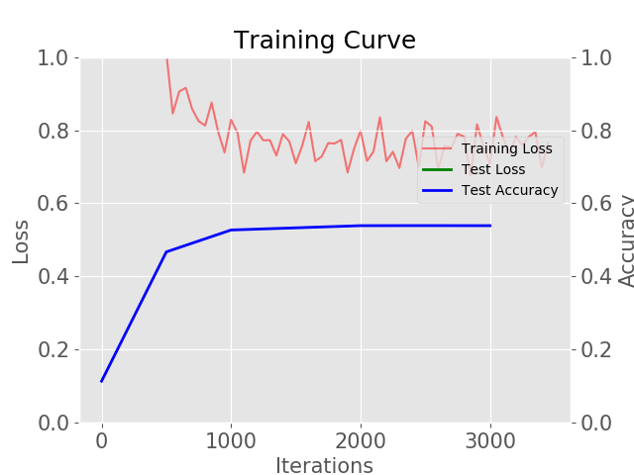
Train with GPU
